8085 Timing Diagrams

8085Instruction Timing and Execution

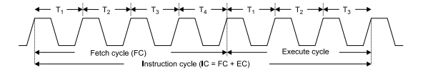

Where, Instruction cycle = Fetch Cycle (FC) + Execute cycle (EC).

[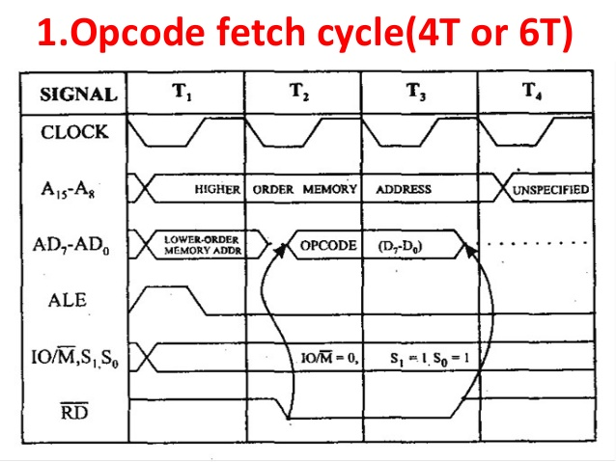](https://www.google.co.in/url?sa=i&rct=j&q=&esrc=s&source=images&cd=&ved=0ahUKEwiG0f-wqqnVAhUGhrwKHXAGC50QjRwIBw&url=https://www.slideshare.net/gokulvlsi/timing-diagram-8085-microprocessor&psig=AFQjCNHE5tq0St4fTWyFZyKO_kv49um2Tw&ust=1501240385523390)

[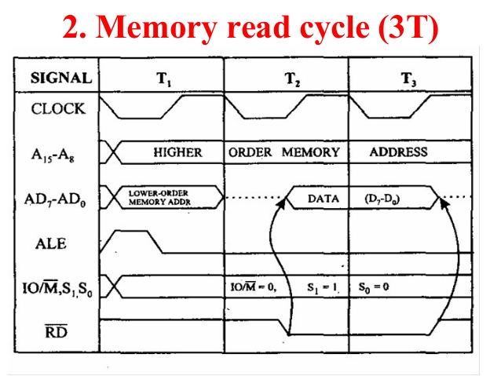](https://www.google.com.my/url?sa=i&rct=j&q=&esrc=s&source=images&cd=&cad=rja&uact=8&ved=0ahUKEwiUlMfFq6nVAhVCa7wKHej0BIsQjRwIBg&url=https://www.slideshare.net/gokulvlsi/timing-diagram-8085-microprocessor&psig=AFQjCNFlzoyM2PVsyPv0OAnJ5l4k0bV7fQ&ust=1501240697011479)

**3.Memory Write Cycle**

[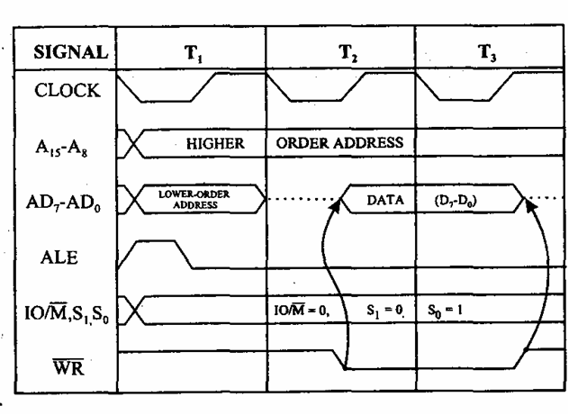](http://www.google.com.my/url?sa=i&rct=j&q=&esrc=s&source=images&cd=&cad=rja&uact=8&ved=0ahUKEwiS9Mzoq6nVAhWLWrwKHSouBcEQjRwIBg&url=http://www.8085projects.info/Memory-Write-IO-Read-Timing-Diagram.html&psig=AFQjCNFHpAL64MJCZtJZpNtzTFsMzTtcUg&ust=1501240757207472)

**4. I/O Read Cycle**

[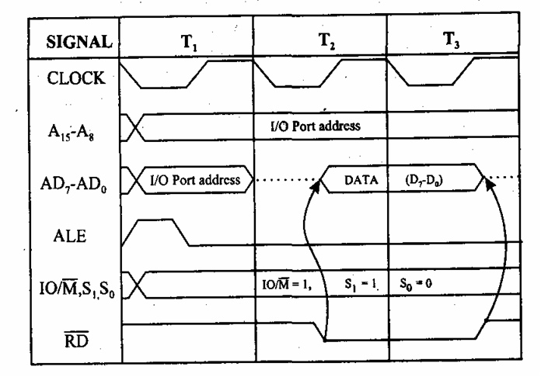](http://www.google.com.my/url?sa=i&rct=j&q=&esrc=s&source=images&cd=&cad=rja&uact=8&ved=0ahUKEwiJr_2LrKnVAhVHVbwKHbfeDhoQjRwIBg&url=http://www.8085projects.info/Memory-Write-IO-Read-Timing-Diagram.html&psig=AFQjCNFHpAL64MJCZtJZpNtzTFsMzTtcUg&ust=1501240757207472)

**5. I/O Write Cycle**

[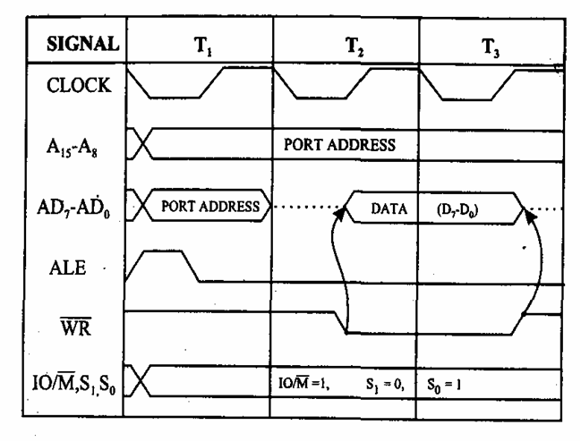](http://www.google.com.my/url?sa=i&rct=j&q=&esrc=s&source=images&cd=&cad=rja&uact=8&ved=0ahUKEwjKhYWxrKnVAhVHTLwKHdX6A44QjRwIBg&url=http://8085projects.info/io-write-machine-cycle-timing-diagram.html&psig=AFQjCNFHpAL64MJCZtJZpNtzTFsMzTtcUg&ust=1501240757207472)